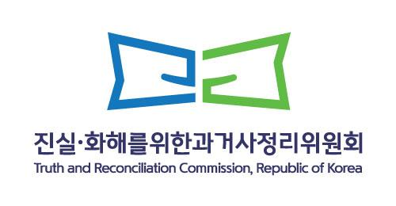 | Press Release |  | Department | Investigation Division 7
 |  |  | Department | Chief. Kyung-mi, Kim
 | Press Release time | 2025. 3. 26.(Mon) 08:00 | Contact  Info. | 02-3393-9950
 | Publication time | 2025. 3. 26.(Mon) 12:00 | Contact  Info. | 02-3393-9950
(04554) Namsan Square 5~6F,173 Toegye-ro, Jung District, Seoul (02-3393-9700)
<3.15 Uprising> (51727) 2 Odongbuk 11-gil, Masanhappo-gu,Changwon-si, Gyeongsangnam-do (055-246-8626)
Head of Public Relation. Ji-hoon, Yang (02-3393-9726) Public Relations Specialist. Young-il, Park (02-3393-9730)
Truth Investigation into Human Rights Violations in the Intercountry Adoption Process Due to the Government’s Systemic Failure in Oversight and Management
- Confirmation of human rights violations including fraudulent orphan registrations, identity tampering, and inadequate vetting of adoptive parents
- Recommendations for an official state apology, ratification of the Hague Convention on Protection of Children and Co-operation in Respect of Intercountry Adoption, and additional corrective measures

- The Truth and Reconciliation Commission of the Republic of Korea (Chairperson: Park Sun-young, hereinafter referred to as the “Commission”) concluded during its 102nd Committee Meeting on the 25th, held at its headquarters in Jung-gu, Seoul, that the government had violated the fundamental human rights of adoptees by sending numerous children overseas without proper legislative frameworks, oversight, or adherence to administrative procedures. This failure resulted in the infringement of adoptees’ rights, which are protected under the Constitution and international conventions.
- This case pertains to a petition filed by 367 adoptees sent overseas between 1964 and 1999 to 11 different countries. These individuals claimed that, during the adoption process, their identities were altered, and they were collectively registered as “orphans,” often through forged documentation that misrepresented their status as abandoned children. As a result, their “right to know their identity” was severely infringed upon.
- In response, the Commission conducted an extensive investigation, gathering a vast amount of data from the National Archives, the Diplomatic Archives, and the Seoul Archives. Additionally, the Commission secured adoption records of 367 petitioners from four major adoption agencies and conducted interviews with relevant government officials, adoption agency and welfare facility staffs, and the biological families of adoptees.
*Holt Children’s Services, Korea Social Service, Korea Welfare Services, Eastern Social Welfare Society

<Overview of Intercountry Adoption in Korea>
Korea’s intercountry adoption practice originated in the aftermath of the Korean War, primarily targeting mixed-race children who were perceived as incompatible with Korea’s ethnically homogeneous society. The enactment of the Special Adoption Act for Orphans in 1961 facilitated expedited intercountry adoptions, which later expanded to include children of unwed mothers, abandoned infants, and children classified as “in need of protection.” The government entrusted all adoption-related tasks – including child intake, adoptive parents screening, legal processing, departure arrangement, and finalization of legal adoption procedures overseas – to private adoption agencies. Between 1955 and 1999, approximately 141,778 children were adopted internationally.

- Based on its two-year and seven-months investigation, the Commission identified the following major issues in the process of Korea’s intercountry adoption:
- For nearly 50 years following the Korean War, the government prioritized intercountry adoption as a cost-effective alternative to strengthening domestic child welfare policies. By delegating full authority over adoption procedure to private agencies without proper oversight, the government failed in its duty to protect children’s right.
- Under relevant legislation*, adoption agency directors were granted extensive authority, including guardianship and the right to consent to adoption. This lack of oversight made it difficult to regulate misconduct by adoption agencies, ultimately resulting in large-scale intercountry adoption of children in need of protection.
*Special Adoption Act for Orphans (1961-1975) and Special Adoption Act (1977-Present)
- The identities and family information of many children were lost, falsified, or fabricated. After being sent abroad, adoptees were left without appropriate legal protections, depriving them of the rights enshrined in the Korean Constitution and the UN Convention on the Rights of the Child.

The Commission confirmed the following specific human rights violations in the
intercountry adoption process (see the attached documents for details)

- Lack of Proper Consent for Adoption: Although the law required the submission of a parental or guardian consent form before proceeding with adoption, numerous cases were identified where proper legal consent procedures were not followed.
- Fabrication of Records, including False Reports of Abandoned Child: Children without birth registration(Ho-juk) were falsely recorded as foundlings at “Orphan Registration” through fabricated reports stating they were abandoned outside the premises of adoption agencies. These false records violated Articles 228 (Falsification of Public Documents) and 229 (Use of Forged Official Documents) of the Criminal Act.
- Tokenistic Public Notice for Guardians: In cases where abandoned children were classified as orphans, a public notice procedure was mandated to verify the existence of legal guardians. However, this process was often perfunctory, with notices being posted at unrelated local offices long after the child’s disappearance.
- Deliberate Identity Substitution: If a child in the adoption process passed away or was reclaimed by their biological family, agencies would substitute another child’s identity to expedite the adoption, severely violating adoptees’ rights to their true identities.
- Inadequate Screening of Adoptive Parents: Despite regulations requiring verification of adoptive parents’ eligibility, an overwhelming majority (99%) of intercountry adoption approvals (as of 1984) were granted on the same day or the following day, rendering the screening process ineffective.
- Neglect of Guardianship Duties: Korean adoption agencies were responsible for acting as guardians until legal adoption procedures were finalized in the receiving country. However, in practice, agencies frequently transferred guardianship through informal declarations before the child even left Korea, neglecting their legal duties.
- Mass Exportation of Children to Meet Demand: Korean adoption agencies complied with foreign agencies’ demands to send a set number of children each month, facilitating large-scale intercountry adoptions with minimal procedural oversight.
- Forced Donations for Adoption Placement: The government failed to regulate adoption fees, allowing agencies to set fees through internal agreements. Furthermore, adoptive parents were compelled to pay additional “donations,” which were used to secure more children for adoption, effectively turning internal adoption into a profit-driven industry.

- The Commission has determined that the long-standing intercountry adoption practices represent a failure of the government to uphold its responsibility to protect the fundamental human rights of its citizens. Accordingly, the Commission recommends the following measures: △An official government apology △A comprehensive survey on adoptees’ citizenship status and corresponding policy measures △Remedies for victims whose identities were falsified △Prompt ratification of the Hague Convention on Protection of Children and Cooperation in Respect of Intercountry Adoption* △Commitment from adoption agencies to restore adoptee’s rights
The Commission urges the government to implement these recommendations to address past injustices and uphold the fundamental human rights of adoptees.
<Hague Convention on Intercountry Adoption >
The Hague Convention on Protection of Children and Cooperation in Respect of Intercountry Adoption was adopted on May 29, 1993, at The Hague Conference on Private International Law and came into effect on May 1, 1995. It establishes procedures and requirement to protect the human rights of children involved in intercountry adoptions and prevent abduction and trafficking. South Korea signed the treaty but, along with Nepal and Russia, has not ratified it.

- Upcoming Engagement: The committee will meet with Norwegian Investigation Committee on Intercountry Adoption (Chair: Ms. Camilla Bernt) on March 27 at 9:30 AM at the Commission’s headquarters to share findings and discuss future cooperation on adoption investigation.

Attached file: Detailed Findings on Human Rights Violations in the Intercountry Adoption Process

Detailed Findings on Human Rights Violations
in the Intercountry Adoption Process



1 | Adoption Procedure Conducted Without Proper Consent

< Case of Applicant P >  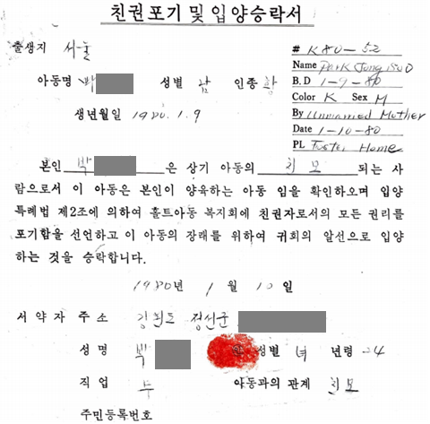 | ☞ The biological mother signed an adoption consent form the day after giving birth at a maternity hospital and entrusted the child to Holt  ☞ Holt took custody of the child after conducting only a single interview with the birth mother, without obtaining any documentation verifying her identity or biological relationship to the child (This violated the Enforcement Regulations of the Special Adoption Act, which mandate confirmation of the identity of the consenting party)
< Case of Applicant K >  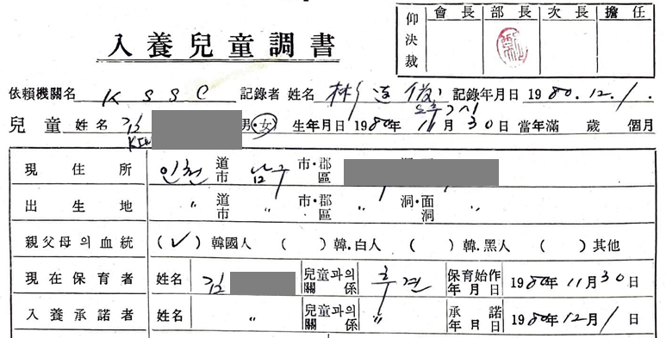  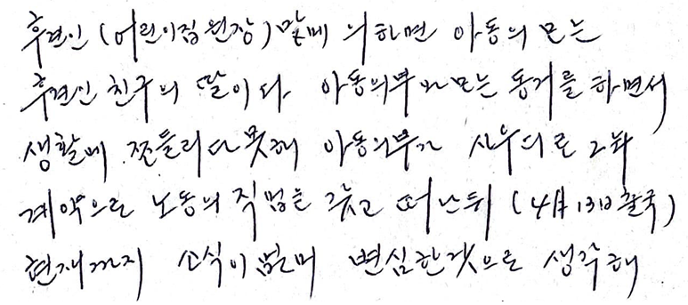 | ☞ A daycare director, who was merely an acquaintance of the child’s maternal grandmother, volunteered as the guardian and requested adoption through the Korean Social Service(KSS) the day after the child’s birth  ☞ This daycare director had no legal basis for acting as the child’s guardian, as there was no biological relationship.  ☞ Neither documentation proving the guardian’s identity nor the birth mother’s adoption consent form was submitted.
2 | Falsified Reports of Foundlings and  Fabrication of Adoption Records

▶ Pre-Filled Foundling Reports with Same Information
< Standard Form for Reporting Foundlings>  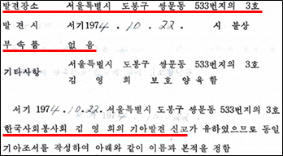 | ☞ When an adoption candidate had no official family registration, the local government created an “Orphan Registration” based on the Foundling Report.  ☞ However, apart from the discovery date, details such as the location, accompanying items, and the identity of the reporter were pre-printed on the form and submitted with identical information each time,
<Case of Applicant S –Request for Protective Custody and Foundling Report >  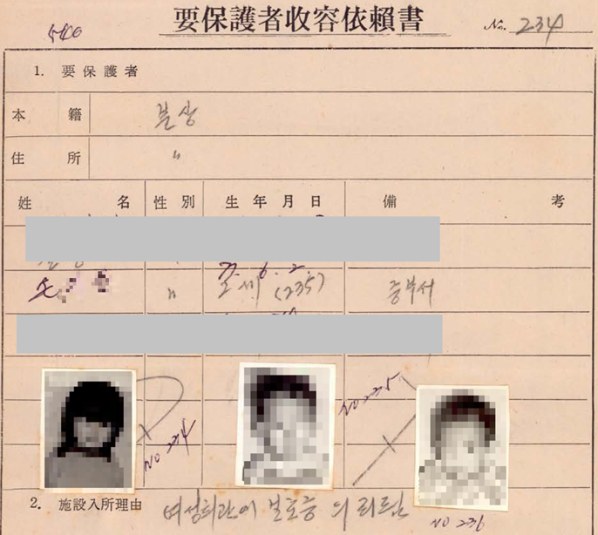  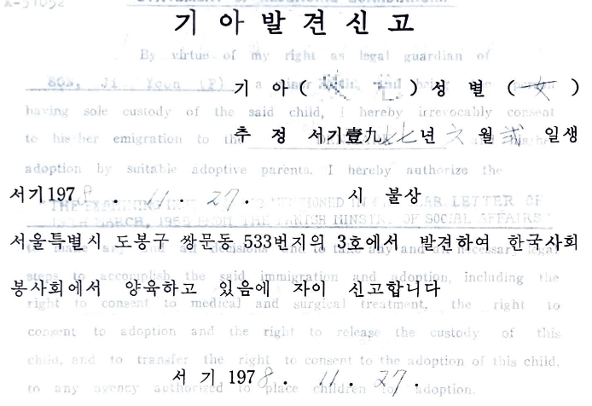 | ☞ ‘Request for Protective Custody’ (Sep. 25, 1978) stated that the adoptee was found by the Busan Jungbu Police Station and transferred to Namgwang Temporary Child Protection Center.  ☞ However, the Foundling Report (Nov. 27, 1978) falsely stated that the child was discovered by the adoption agency, Korea Social Service(KSS).
▶ Falsified Adoption Records (English)
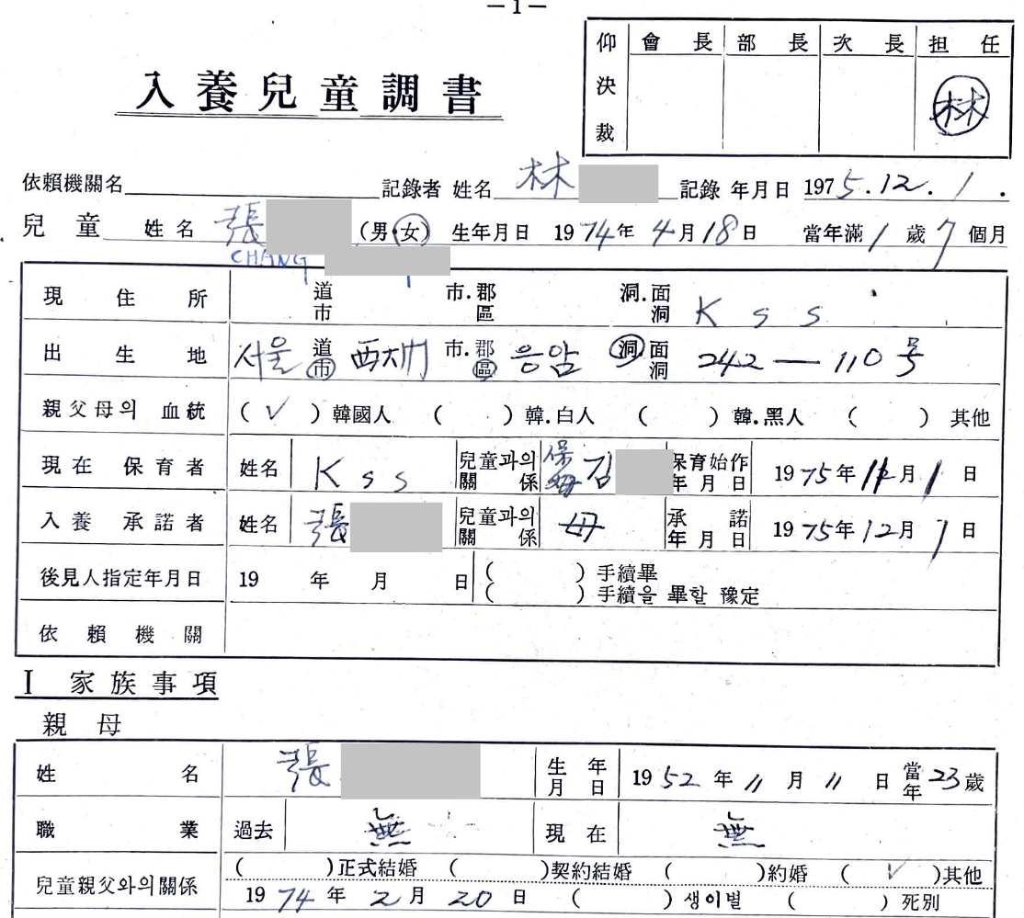
▲ The initial adoption request record for Applicant J accurately documented the birth mother’s personal details and birthplace (Seoul).
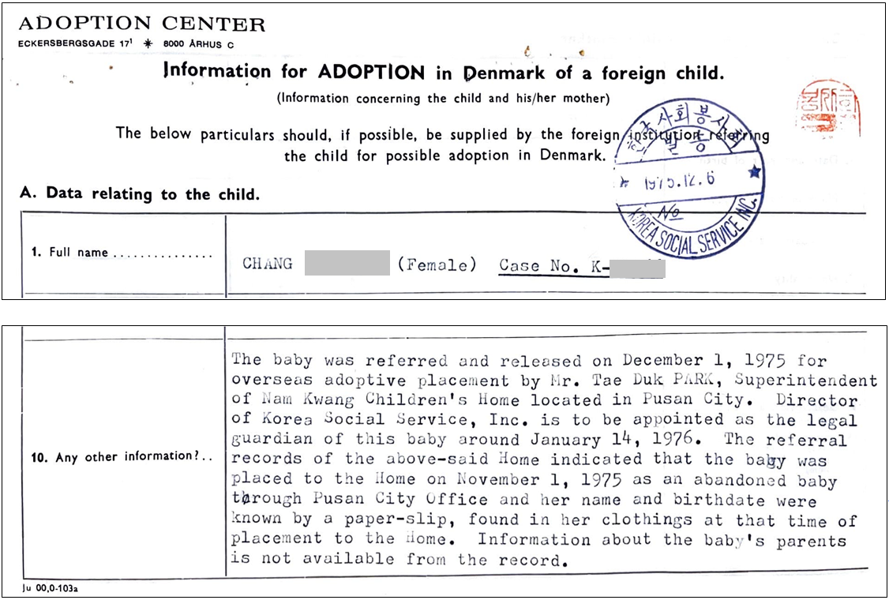
▲ However, the English version of adoption record provided to the adoptive parents falsely stated that the child was entrusted to Namgwang Children’s Welfare Center in Busan, and that the birth parents were unknown.
3 | Token Public Notice of Ascertainment of Support Provider

<Public Notice of Ascertainment of Support Provider>
Prior to adoption, efforts were made to locate the child’s biological family through a public notice procedure. Under the Special Adoption Act for Orphans (1961-1976), local courts posted notices in newspapers and on courthouse bulletin boards twice at 20-day intervals after receiving an adoption application. Under the Special Adoption Act and Facility Minor Guardianship Act Enforcement Decree (1977~), the head of the child protection facility was required to request a public notice through the local government.

▶ Public Notices Issued in Locations Unrelated to the Child’s Discovery
<Case: Public notice locations for 21 children adopted from Brother’s Home>
Initial Facility | Transferred Facility | Public Notice Location  (District Office) | Number of Children
Brother’s Home (Sasang-Gu, Busan) | Busan, Namgwang Children’s Welfare Center | Dongnae-gu, Busan | 1
Brother’s Home (Sasang-Gu, Busan) | Busan Deokseong Orphanage | Haeundae-gu, Busan | 2
Brother’s Home (Sasang-Gu, Busan) | KSS | Gangnam-gu, Gangdong-gu, Seoul | 15
Brother’s Home (Sasang-Gu, Busan) | Holt | Mapo-gu, Seoul | 1
Brother’s Home (Sasang-Gu, Busan) | Eastern (ESWS) | Seodaemun-gu, Seoul | 2

▶ Notices That Omitted Crucial Details of the Child’s Discovery
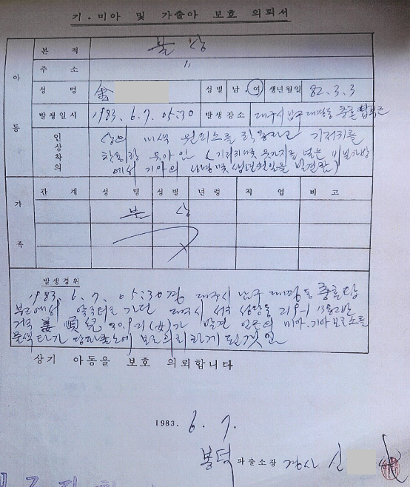 | 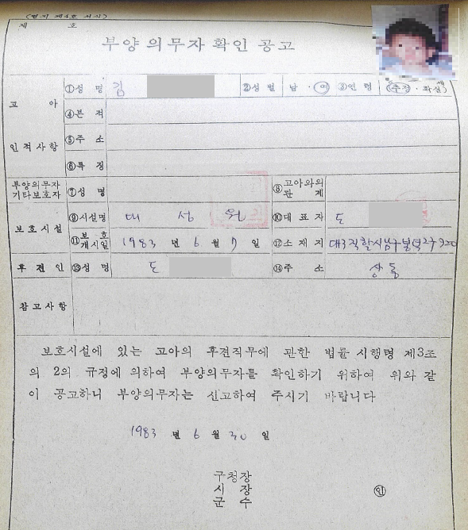
▲Request for Protection of a Found Child: Provided detailed information about the discovery. | ▲Public Notice of Ascertainment of Support Provider: Omitted key details such as discovery location and time
4 | Deliberate Neglect of Finding Birth Families  by Adoption Agencies

Employee Training Material from an Adoption Agency Head (1984)
“In a country like ours, where many children are abandoned, it is practically unclear how the government or adoption agencies can locate the biological parents. The media, being a business, is unlikely to post daily free advertisements in newspapers to help find parents…”

(Referring to the mandatory 6-month waiting period for finding birth families) To prevent incidents that might happen once in a decade, we would tie up a large number of children in uncomfortable environments, and the costs for this would be entirely borne by the foreign adoptive parents. This is something that cannot be justified.”
[Media] Dong-A Ilbo, “Kidnapped Daughter Tracked for 1 Year and 3 Months, Adopted by American Family Due to Adult Indifference,” May 16, 1979.
- In February 1978, a 9-year-old girl, A, from Pohang, followed a junkyard worker, S, and went missing.
- After hearing from S’s friend that he was imprisoned in Daegu Prison, detectives visited him, where he revealed that he had abandoned the child in Busan’s Nampo-dong. Following this, the child went through a police station and child protection center before being adopted by an American family after a year via an adoption agency.
- When the child’s biological father, J, filed a complaint, an adoption agency staff member reportedly responded, “I have no obligation to search for parents using my own money, so feel free to report me if you want.”
[Media] Dong-A Ilbo, “Grandmother Searching for Lost Grandson Finds Him Already Adopted by an American Family”, Sep 24, 1986.
- K (61), a grandmother, lost her grandson S (6) while temporarily visiting Korea from the U.S. and searched for him for three years. It was later confirmed that S was adopted by an American family after being lost.
- After seeing news coverage of the case, a writer wrote a short story based on it, and coincidentally, a foster mother from the Korea Social Service (KSS) contacted K to inform her that S had been adopted.
- KSS sent staff to the U.S. to persuade the adoptive parents, but failed. They then informed the grandmother’s side, “Due to adoption regulations, we cannot reveal the adoptive parents’ address or arrange a direct meeting with S. We can offer financial compensation, but you must relinquish your claim to him.”

5 | Intentional Replacement of Children’s Identities

<Identity Replacement>
If a child undergoing adoption procedures died before departure or was reclaimed by their biological family, adoption agencies sometimes assigned a different child to the same case, using the original child’s identity to expedite the process. This practice helped agencies avoid refunding adoption fees and bypass administrative procedures for newly acquired children. However, it was an illegal act that made it difficult to trace the true origins and identities of adoptees.

▶ Case of Applicant K
Substituted Child: E (Jan 25, 1976) | Applicant: K (Jan 25, 1976)
1976. 12. 15. E was found abandoned in Seoul  1976. 12. 20. A falsified record was sent to Denmark stating that the child had been referred by Namgwang Children’s Welfare Center in Busan.  1976. 12. 30. Orphan Registration  1977. 2. 16. Obtained permission for overseas emigration.  1977. (Date Unknown) Presumed death of E | 1977. 3. 14. The applicant K was born to an unmarried couple and raised by his uncle before being entrusted to an adoption agency.  1977. 3. 15. K’s identity was switched with that of E, whose adoption process was already in its final stages. Just one day after being entrusted for adoption, K was sent to Denmark under falsified identity.
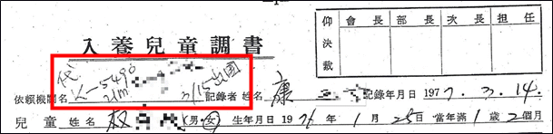

The Adopted Child Report for K records that he departed for Denmark on March 15 under the name of another child, E (listed in English). The adoption agency, Korea Social Service(KSS), did not inform the adoptive parents of this identity swap. It was only in 2009, when the adoptive parents and the applicant visited Korea, that this fact was finally disclosed to them.

▶ Case of Applicant J
Substituted Child: P (Apr 15, 1973) | Applicant: J (Mar 15, 1975)
1973. 5. 8. P found abandoned in Dong-gu, Incheon, and placed in ‘Star of the Sea Children’s’ Home’. KSS prepared him for adoption to Denmark  1973. 6. 8. A U.S. serviceman named Mr. A visited ‘Star of the Sea’ and expressed interest in adopting P privately.  1973. 6. 26. P was privately adopted by Mr. A and his adoption process through KSS was canceled. | 1973. 10. 20. The biological father of J requested adoption through KSS.  1973. 10. 28. Instead of processing J under his real identity, the adoption agency switched his identity to that of P, who had already been prepared for adoption. J was sent to Denmark only a week after the request
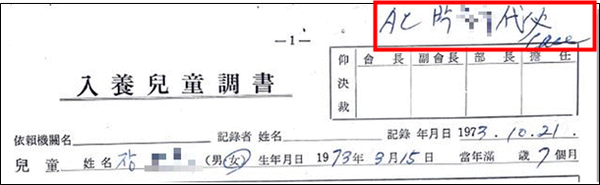
The adoption record of applicant J states that it was a case of substitution, with another child, P, being used in place of the applicant.

6 | Inadequate Screening of Adoptive Parents

< Qualification on Adoptive Parents on Adoption Act >
Special Adoption Act for Orphan (1961. 9. 30.) | Special Adoption Act (1977. 1. 31.)
1. Eligibility to adopt under their home country’s laws  2. Sufficient financial resources to support the child  3. Good moral character with no criminal background  4. Prohibition of using the child for labor, servitude, or other human rights violations  5. A commitment to granting religious freedom and ensuring the child’s social integration, with certification from public authorities | 1. Compliance with their home country’s adoption laws  2. Sufficient financial means to support the child  3. Prohibition of using the child for exploitative labor or degrading occupations  4. Assurance of religious freedom and appropriate upbringing as a member of society

▶ Overseas Emigration Permit: A mere Formality

☞ The Ministry of Health and Social Affairs conducted the only available screening process for adoptive parents
☞ A former official from the Ministry’s Women and Children’s Bureau stated: “It was practically impossible to thoroughly review thousands of intercountry adoption cases annually.”
☞ In 1984, out of 7,964 applications for emigration via adoption, 6,599 (82.9%) were approved on the same day, and 1,279 (16.1%) the following day

▶ Case of Ineligible Adoptive Parents in Norway (Applicant K)
Notification from the Norwegian administrative authorities to the adoptive parents of K
 | English
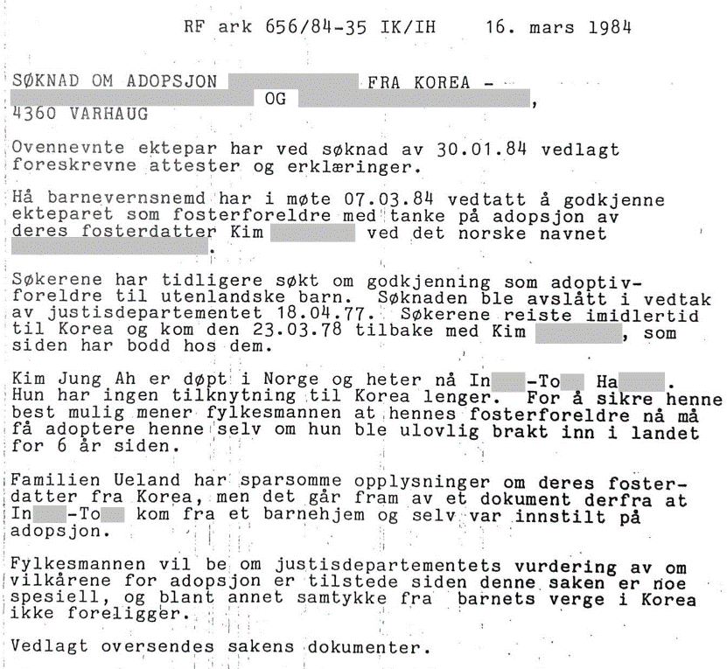 | (…)  The applicants have previously applied for approval as adoptive parents of foreign children. The application was rejected in a decision by the Ministry of Justice on 1977. 4. 18. However, the applicants traveled to Korea and on 1978. 3. 23. returned with Kim **** ** who has since been staying with them.  Kim Jung Ah was baptized in Norway and is now called In***-To** Ha****. She has no connection to Korea anymore. In order to secure her as best as possible, the county governor believes that her foster parents must now be allowed to adopt her, even though she was illegally brought into the country 6 years ago.
[자료 해설]
☞ A Norwegian couple in their mid-50s was denied approval from Norwegian authorities due to their age
☞ However, Mr. and Mrs. A visited an orphanage in South Korea and unlawfully took K, who was already a middle school student, to Norway, where they raised the child. Six years later, they submitted a retroactive adoption application to the Norwegian administrative authorities.
☞ Norwegian authorities acknowledged the illegality but approved the adoption due to the child’s prolonged residency(for six years) and lack of Korean ties

7 | Mass Exportation of Children to Meet Demand

▶ Adoption Agencies Prioritizing the Demand of Adoptive Parents
Correspondence between KSS and the Danish Adoption Center (1971 ~ 1972)
Adoption Center → Korea Social Service (1971. 9. 17.)

Korea Social Service → Adoption Center (1971. 9. 23.)
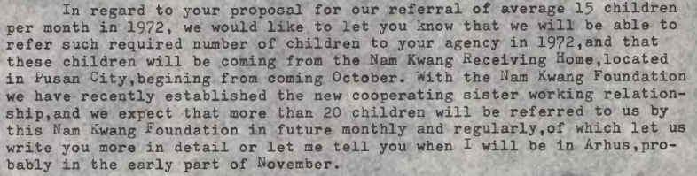
Meeting with Paik (Chair of Korea Social Service) (1972. 5. 14.)
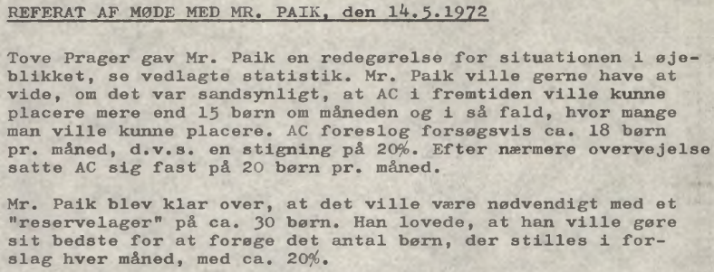
Adoption Center (Chair: F. Lund Nielsen) & Korea Social Service (Chair: Paik) Meeting (1972. 10. 8.)
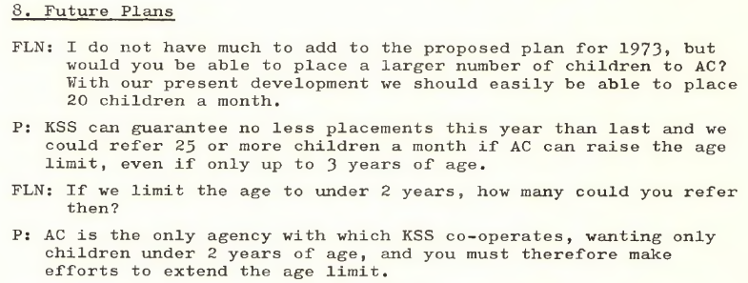

▶ Mass Transportation of Children Like Cargo
1984 Annual Report of the Danish Adoption Center featured an image captioned
“On the way home from Korea”
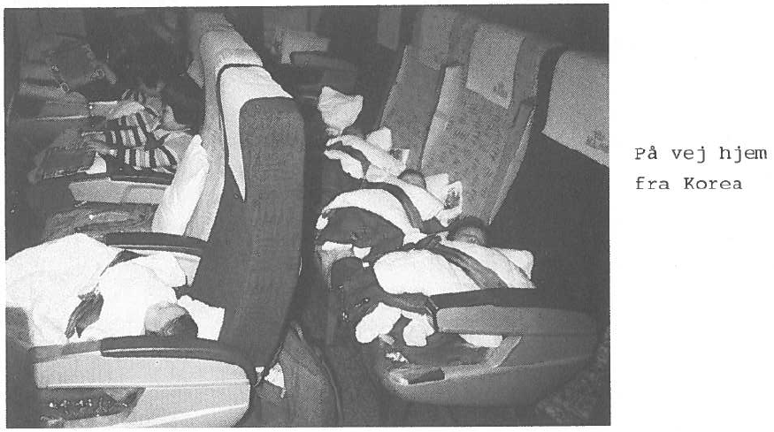
[자료 해설]
☞ Large numbers of children endured long flights strapped to airplane seats without proper care
☞ A 1974 case documented a lactose-intolerant child dying upon arrival in Denmark after being fed milk during transit. (‘Adoptionsfor-midlingen fra Sydkorea til Danmark I 1970’ erne og 1980’erne’, Ankestyrelsen, 2023)

<Comparison of Intercountry Adoption Procedures for Children Sent to the Netherlands in 1980>
Country | Adoption Processing Time | Parental Visit Requirement | Other Details | Adoption Cases(person)
India | Several months to 1 year (frequent cases of withdrawal of parental relinquishment decisions) | Not required | Sibling adoptions not allowed | 133
Indonesia | 3-7 months (from submission of the adoption application to child assignment; additional time required for the actual transfer of the child) | Mandatory Parental visit  3 week stay required | - | -
Columbia | 2-18 months for child assignment; 2months to 1.5 years for the child’s arrival in the Netherlands | At least one parent required | - | 120
Ecuador | Generally long (some under 5 months) | Not requied | - | 6
South Korea | 6 weeks to 2.5 months from parental consent to child transfer | Not required | Sibling adoption allowed | 180
※ Source: Dutch adoption agency ‘Wereldkinderen’

8 | Forced Donations for Adoption Processing

▶ Hidden Adoption Fees and Forced Donations
☞ In 1977, the enactment of the Enforcement Decree of the Special Adoption Act formally specified provisions related to adoption fees. However, the Ministry of Health and Social Affairs failed to establish enforcement regulations to define the scope of these fees.

* Article 8 of the Enforcement Decree of the Special Adoption Act:
“Adoption Agencies may receive reimbursement from the prospective adoptive parents, within the range determined by the Minister of Health and Social Affairs, for all or part of the costs incurred in the adoption process”

☞ Due to the lack of a properly established legal framework, the ceiling on adoption fees was determined through negotiations between adoption agencies, with subsequent approval from the Ministry of Health and Social Affairs.
* As of 1982, the fee per child was $1,450 USD (approx. 1.06 million KRW at the time)

☞ Amid the government’s lack of oversight, adoption agencies not only collected the officially reported adoption fees but also imposed mandatory “donations” on adoptive parents and foreign adoption agencies. These donations significantly exceeded the actual adoption costs, generating substantial profits.

Case of Forced Donation
Korean Social Welfares, “Correspondence with adoption agency regarding adoption fee” 1982. 10. 20.
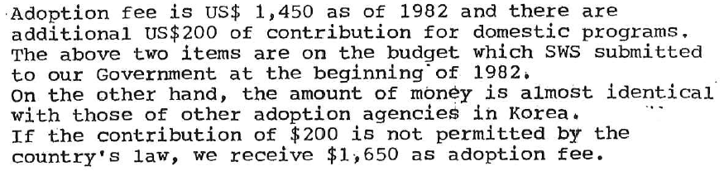
Korea Social Service→ Adoption Center (Denmark) 1988. 7. 27.


▶ Donations: Payments for Child Export and Investment in securing a stable supply of adoptable children

☞ The mandatory donations were not merely used to cover processing costs; they were reinvested into facilities responsible for securing adoptable children (such as orphanages, maternity homes, birthing centers, and hospitals), thereby perpetuating the cycle of child supply for intercountry adoption.

☞ As international criticism over “orphan exports” intensified around the 1998 Seoul Olympics, the South Korean government attempted to significantly reduce the scale of intercountry adoptions. In response, the Adoption Center(AC) indicated to the Korean Social Welfare Society that the substantial amount of donations they had provided could be discontinued. This strongly suggests that these so-called donations were not humanitarian in nature but rather constituted a commercial transaction of children.

Recorded phone conversation between AC Representative FLN and the President of the KSS, K
1989. 5. 9. ~ 7. 27.
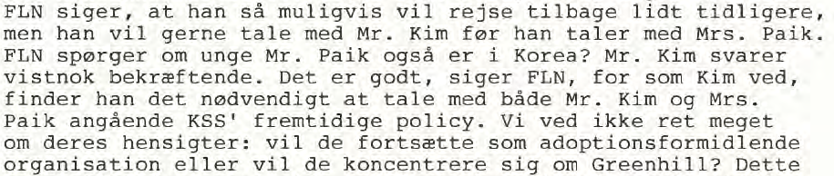
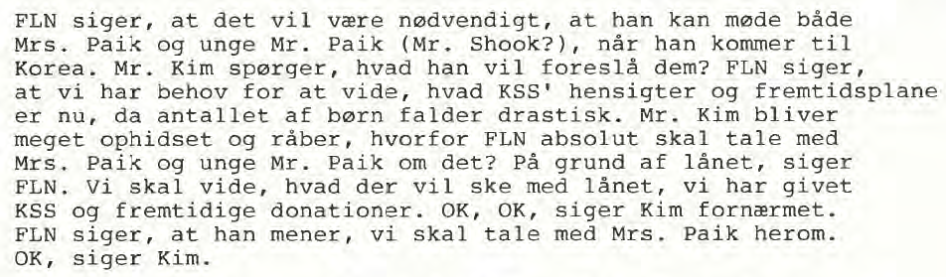

※ UN’s Stance on “Donations” in the Adoption Process:
The UN has expressed concerns that if child welfare institutions rely financially on adoption agencies, they may be compelled to maintain a steady supply of adoptable children for their own survival. This, in turn, increases the likelihood of illegal adoptions.

9 | Commodification of Adopted Children  “Discounted Fees for Disabled Children”

1975. 11. 26. Danish newpaper EKSTRA BLADET reported
≪ Disabled child for 3,600 – Healthy child for 10,000 ≫
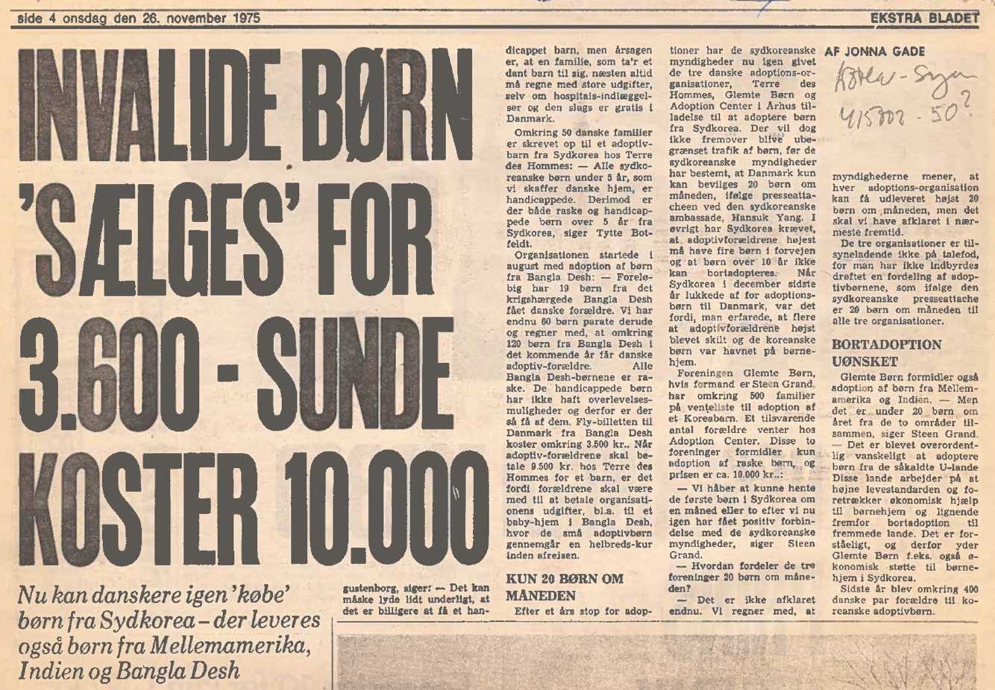
“Once again, Danes can ‘purchase’ children from South Korea. They can also obstain children from Central America, India, and Bangladesh. The price of a healthy child from South Korea is approximately 10,000DKK, while a disable dchild can be acquired for the price of a planeticket- 3,600DKK The cost is the same for children adopted from Bangladesh, Central American and India.”

Approximately 50 Danish families have registered with TDH to adopt children from South Korea. Tytte Botfeldt, a representative of TDH, stated that all South Korean children under the age of five being provided do Danish families have disabilities, while those over the age of five include both healthy and disabled children.

10 | Failure of Guardianship and Abandoned Adoptees

▶ Cases of Children Returned by Adoptive Parents
Adoption Center → KSS (1983. 11. 22.)
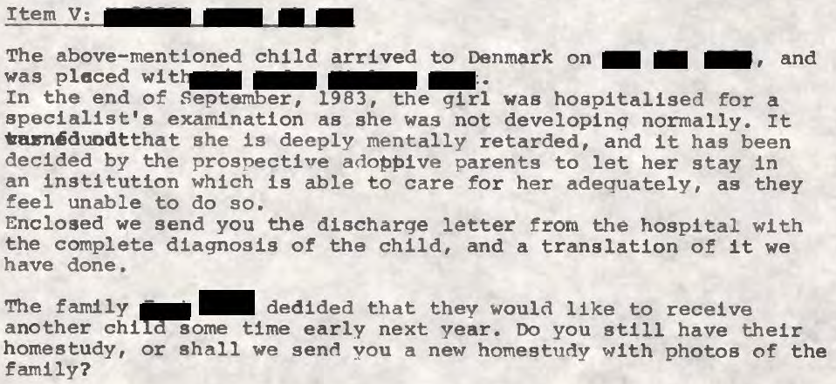

▶ Pre-citizenship Guardianship Abandonment by Adoptive Agencies
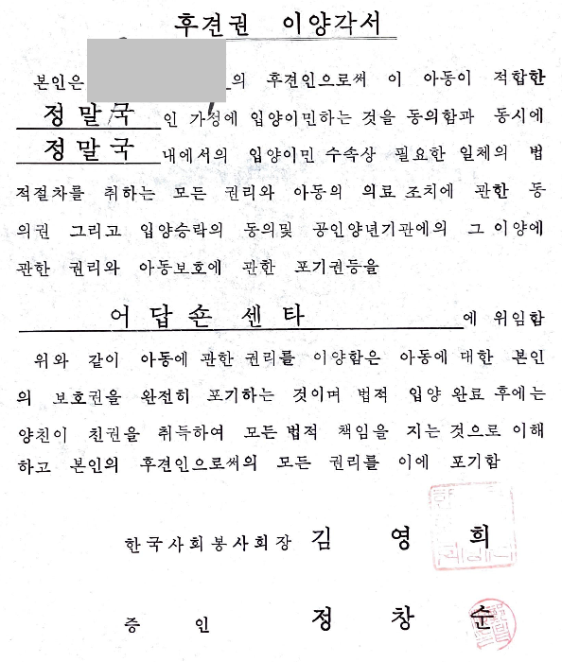 | ☞ Special Adoption Act (1977.1.31.) Article 12  “The head of an adoption agency, upon receiving a child for adoption from the head of a care facility, shall perform the duties of a guardian from the date of receipt until the adoption in finalized.”  - “According to the above provision, the adoption agency must fulfill its duties as a guardian until the adoption process is completed, even in cases of international adoption. The obligation is now waived merely by drafting a ‘Guardian Transfer Agreement’ at will. (Seoul Central District Court, May 16, 2023, Case No. 2019GaHap5502520) ”

‘Public Notice of Ascertainment of Support Provider’ (Ministry of Health and Welfare of Republic of Korea)

